

**HITEC UNIVERSITY TAXILA, CANTT**

**BSAI-(B)-1st Semester**

**LAB REPORT**

**AICT Project**

**Fall 2024**

**Submitted To:**

Ms. AMNA SHAKEEL

**Submitted By:**

Sameer Ahmed (24-ai-013)

Hassan Minhas(24-ai-009)

Abdullah Tahir(24-ai-029)

**BS ARTIFICIAL INTELLIGENCE**

**PROGRAM DEPARTMENT OF COMPUTER SCIENCE __________UNIVERSITY, TAXILA____________**

**Proposal for Pet Shop Website**

**Introduction**

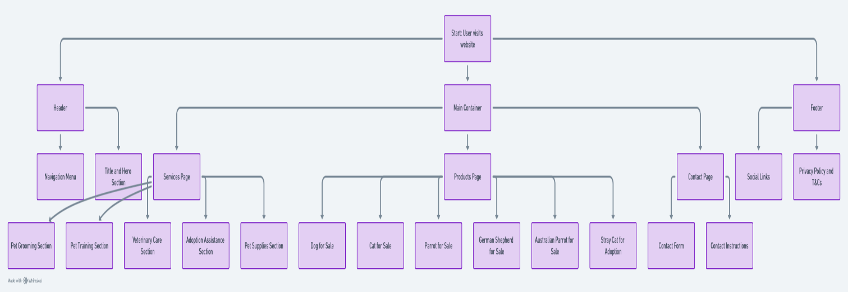I’m pleased to present the HTML code for our Pet Shop website, designed to showcase a wide variety of pets available for sale and adoption. The site aims to create a friendly and engaging experience for visitors looking to find their perfect pet.

**Website Structure**

1. **Header**

The header features a prominent title, "Our Pet Products," accompanied by a navigation menu. The menu contains links to:

• Products Page: Directing users to our pet listings.

• Services Page: Highlighting additional services we offer.

• Contact Page: Providing a way for customers to reach out with inquiries.

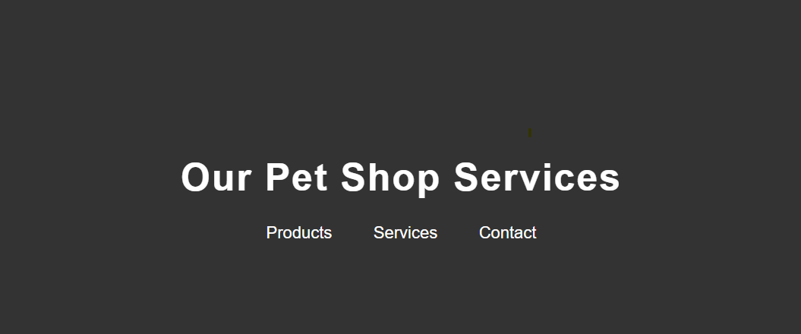

2. **Main Content**

The main section is organized into product categories, making it easy for visitors to browse through our offerings:

• **Dog for Sale:** Showcases a Friendly Labrador Retriever with a detailed description, age, and price (Rs 10,000). It includes a contact button for easy inquiries.

• **Cat for Sale:** Features a Playful Persian Cat with similar information (Rs 7,000), highlighting its friendly nature.

• **Parrot for Sale:** Displays an Exotic Green Parrot, known for its lively personality and training (Rs 5,000).

• **New Additions:**

o A Loyal German Shepherd (Rs 20,000) is introduced, excellent for families and outdoor activities.

o A Friendly Australian Parrot (Rs 3,000) is also included, noted for its intelligence and sociable nature.

• Stray Cat for Adoption: This section promotes a Caring Stray Cat that needs a loving home (Rs 2,000), encouraging adoption and community involvement.

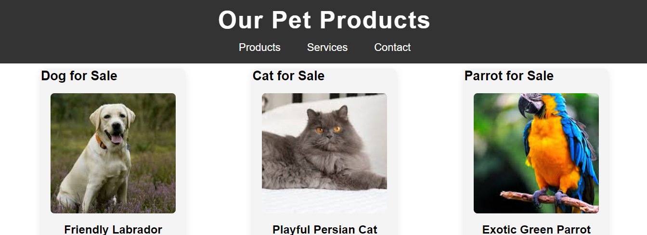

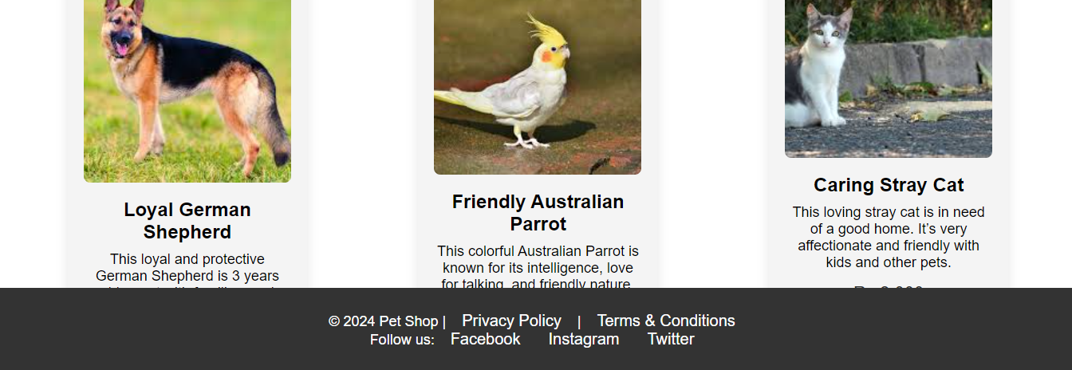

3. **Footer**

The footer includes copyright information for 2024, links to our privacy policy and terms & conditions, and social media links to platforms like Facebook, Instagram, and Twitter, allowing visitors to connect with us easily.

**Conclusion**

This website is structured to enhance user experience while offering clear and appealing presentations of our pet products. I believe this layout will attract potential buyers and adopters. I welcome any feedback you may have to make the site even better.